AnyConnect VPN Client
Steps to Download and connect to THE USC network
USC-ITS
2020
Login and Download VPN Software
- Connect to local wifi.
- Go to https://vpn.usc.edu.
- On the login screen, Enter your USC NetID and Password.
- Click .
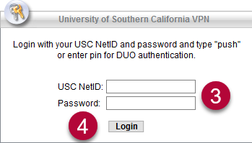
- After you have logged in, click on the left.
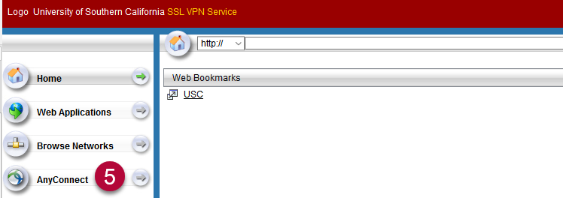

- In the middle of the screen, click .
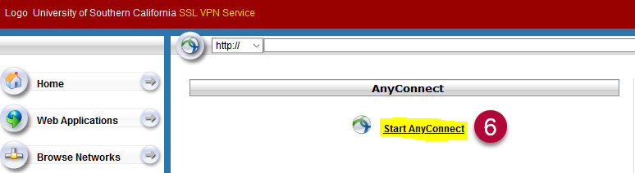

- On the Download & Install screen, click . You may be prompted to save the file, or it may automatically download to your Downloads folder.
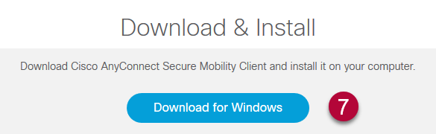
Install VPN Software
- Search for the downloaded file on your computer and double-click it.
  - You may see the file in the bottom left-hand corner of your screen.
  - If you do not, look in your Downloads folder.
- A Cisco AnyConnect Secure Mobility Client Setup pop-up window appears. Click . This will initiate the installation.
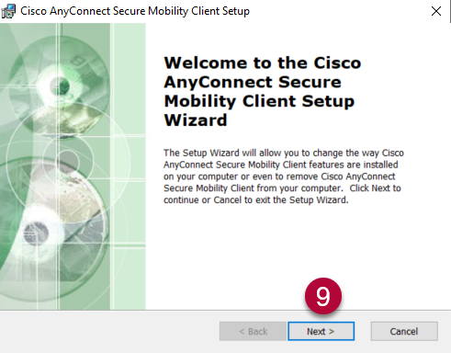

- On the End User License Agreement window, select
- Then click .
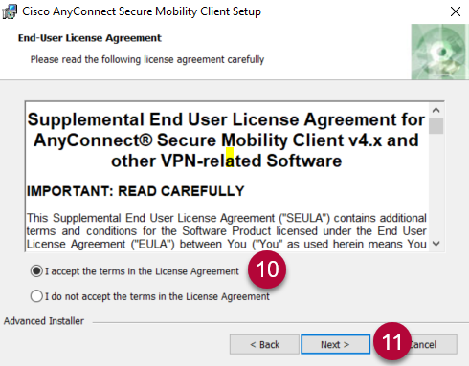

- Click . The installation will begin.
  - If prompted to allow the installation, click Yes.
  - If prompted, enter your computer’s Admin ID and password. This is the ID and password you use to log into the computer.

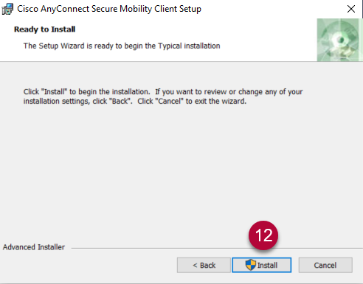

- When the installation is complete, click .
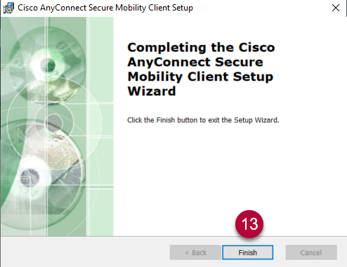

Connect to VPN
- Search for the Cisco AnyConnect Secure Mobility Client app on your desktop (Type “Cisco AnyConnect” in your computer search bar OR select the Windows Start button and search in the menu items).
- Click to open the application.
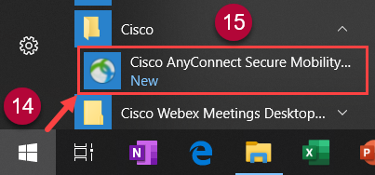
- In the VPN pop-up window, enter “vpn.usc.edu”
- Then click .
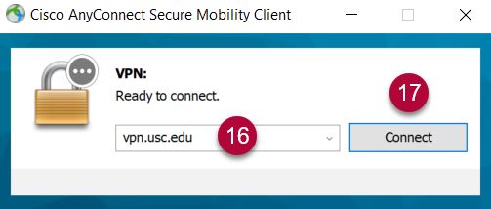

- On the login screen enter your USC user ID and password.
- Click .
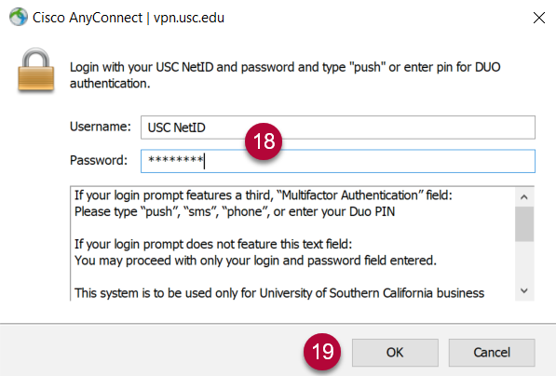

- You are now connected to the USC network through VPN.

