AnyConnect VPN Client
Steps to Download and connect in MAC
USC-ITS
2020
Login and Download VPN Software
- Connect to local wifi.
- Go to https://vpn.usc.edu.
- On the login screen, enter your USC NetID and Password.
- Then click .
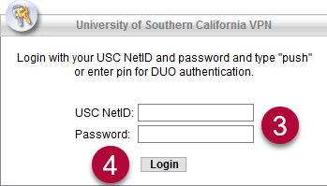
- After you have logged in, click on the left.
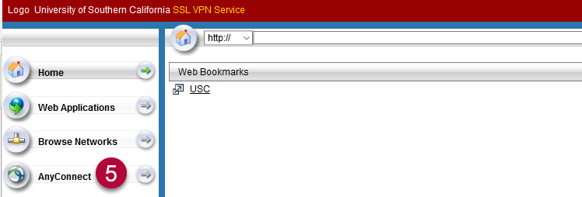
- In the middle of the screen, click .
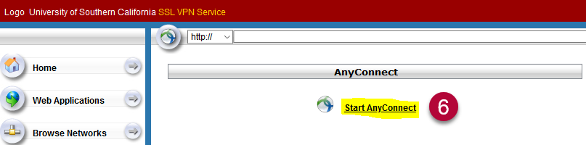
- On the Download & Install screen, click .
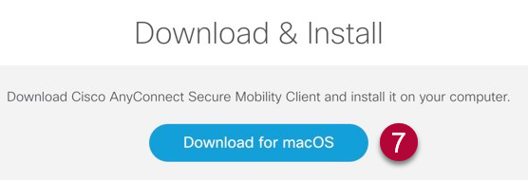
Install VPN Software
- Search for the downloaded file on your computer and double-click it.
- An Install AnyConnect Secure Mobility Client pop-up window will open. Click . This will initiate the installation.
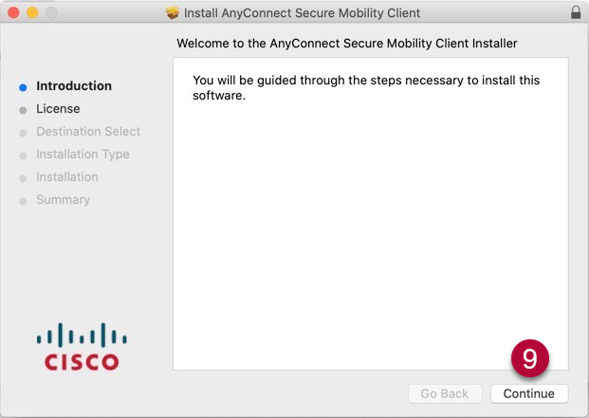

- On the Software License Agreement screen, click .
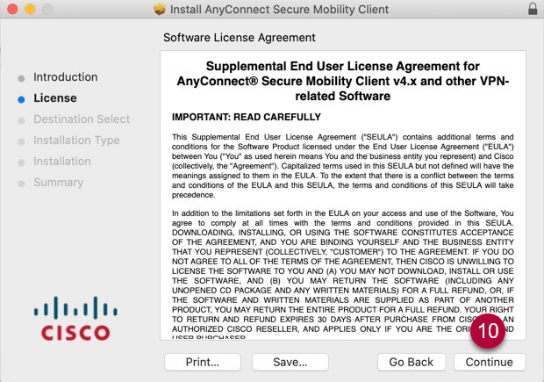

- On the pop-up window, click .
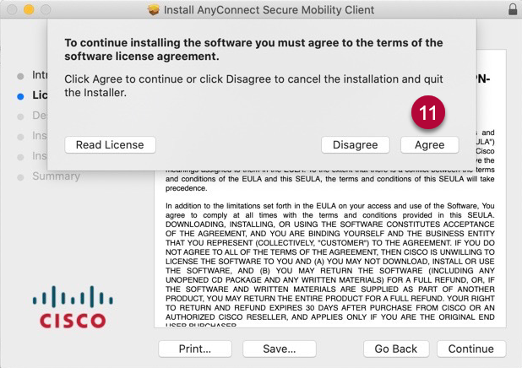

- On the Standard Install on “Macintosh” screen, click .
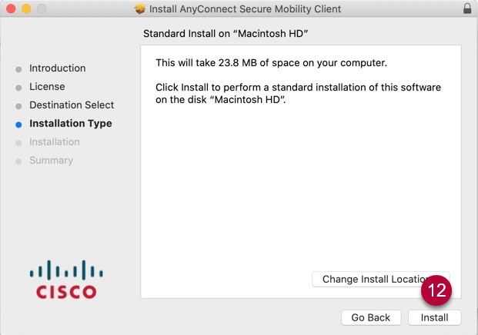

- In the pop-up window, enter your computer administrator Username and Password.
- Then click .
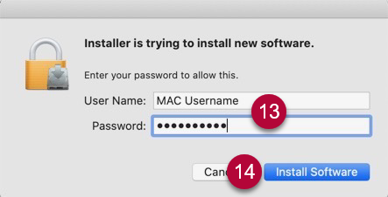

- The installation will begin. When prompted, click .
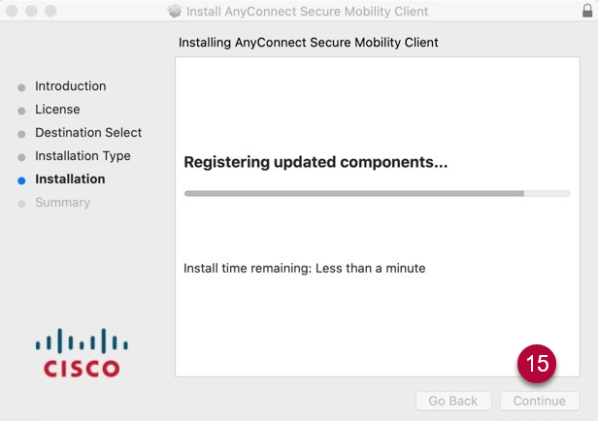

- When the installation is complete, you will see the message “The installation was successful. The software was installed.”
- Click .

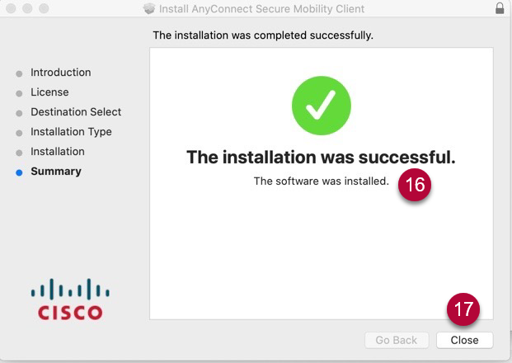

Connect to VPN
- Search for the Cisco AnyConnect Secure Mobility Client app on your desktop (Type “Cisco AnyConnect” in your computer search bar).
- Open the application.
- In the AnyConnect pop-up window, enter: “vpn.usc.edu”
- Click .
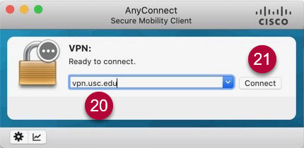
- On the login screen, enter your USC user ID and password.
- Click .
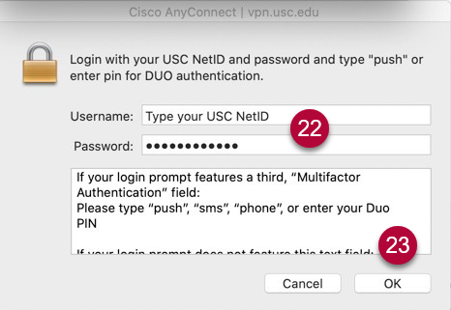

- You are now connected to the USC network through VPN.

