Reassign Zoom Session to New Host

- Log onto usc.zoom.us.

- Click Meetings in the left panel.

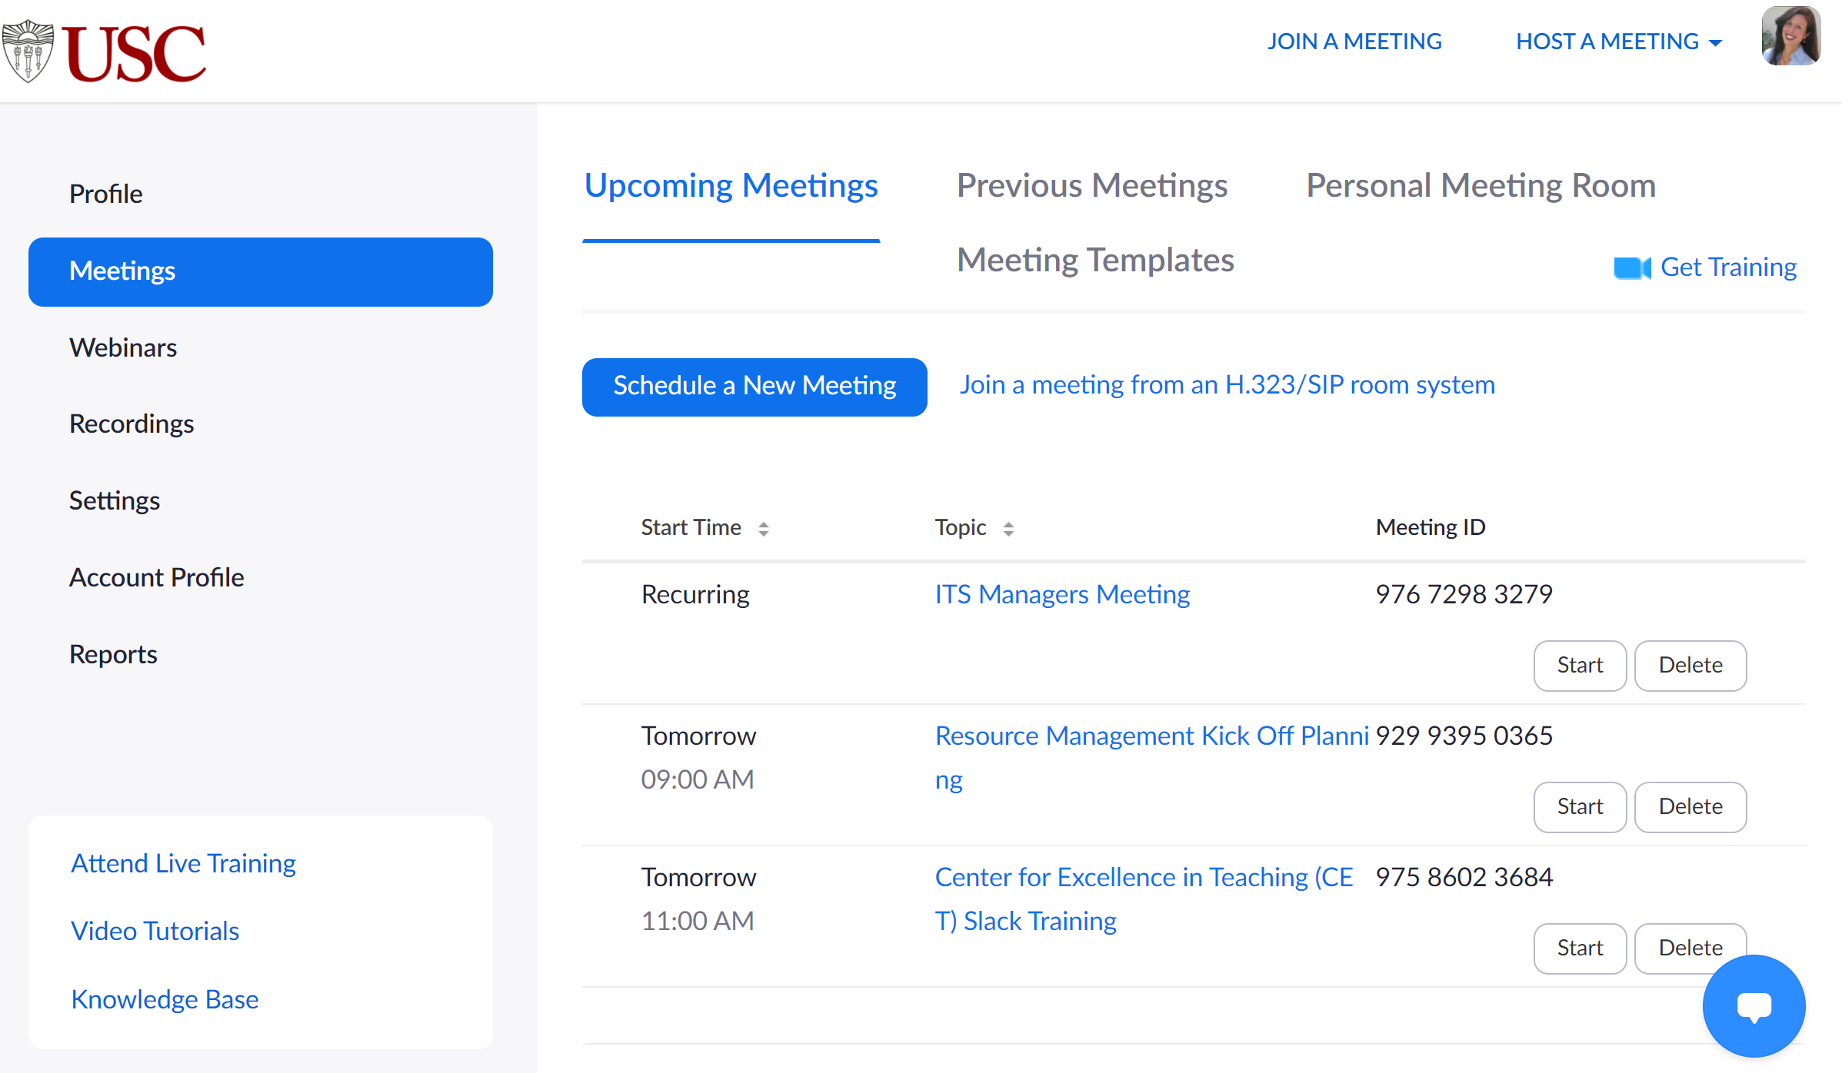
- Click the Delete button next to the meeting instance for the lab.
- Ask TA to logon onto Blackboard.
- Ask TA to Set up a Zoom Meeting from Blackboard with TA as host as shown in this video.

