Provide Single Zoom Link to All Students

If two classes were set up for the same section, you will need to provide a single Zoom meeting link to all students and here is how to do that:

- Log onto usc.zoom.us.

- Click Meetings in the left panel.

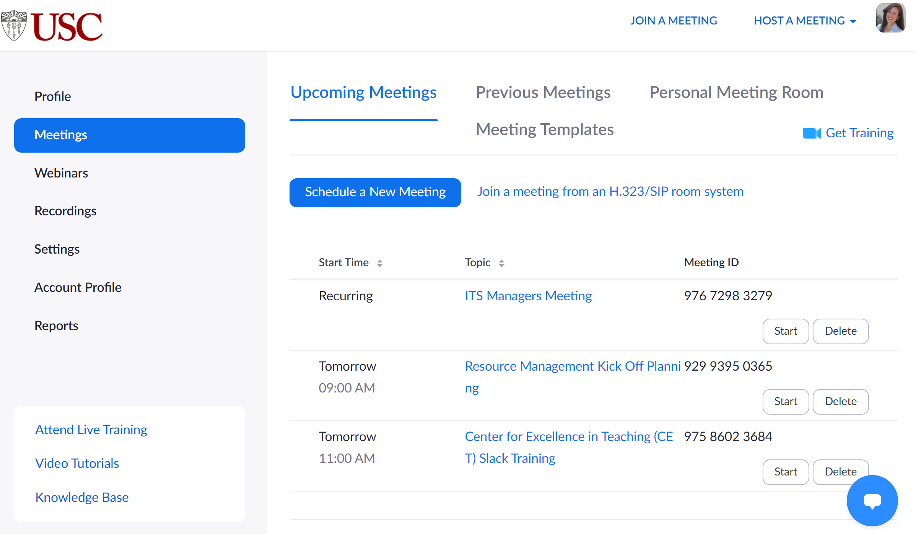
- Click the first of the two class instances that are double-booked.
Section 1
Section 2

- Click Copy Invitation.
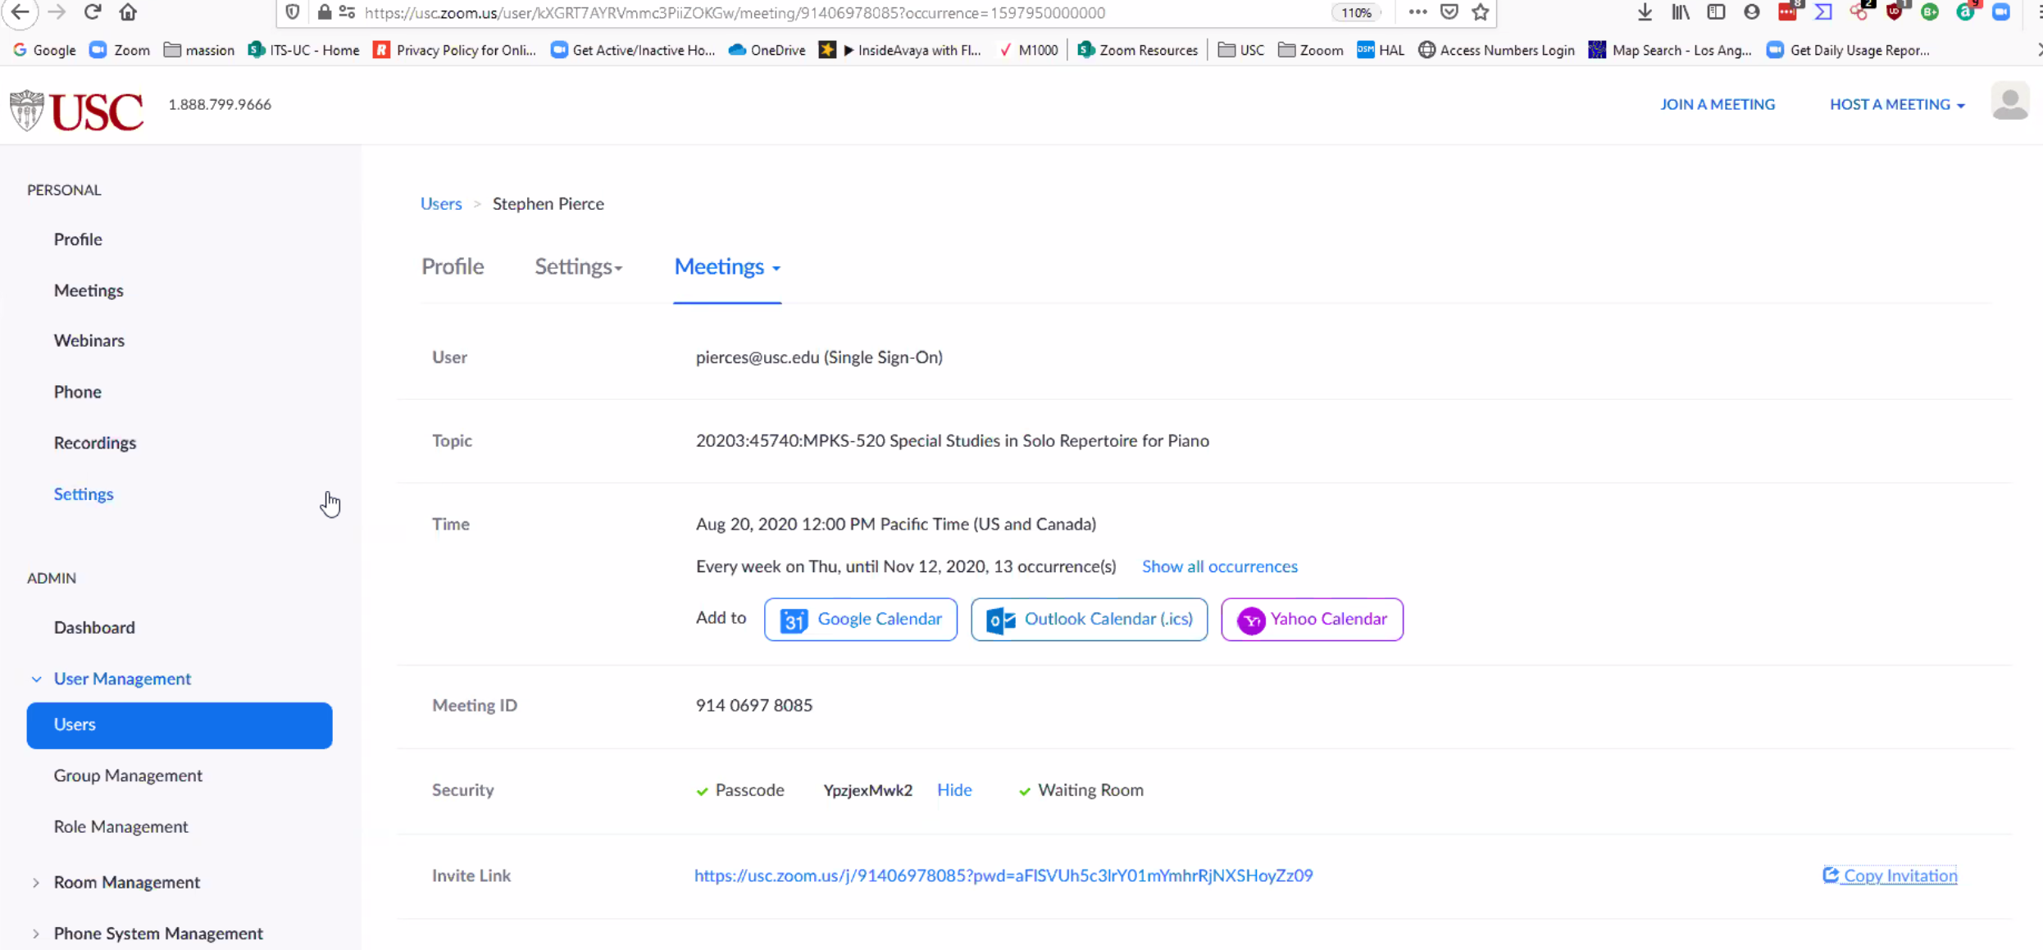
- Click the Copy Invitation button on the pop-up screen.
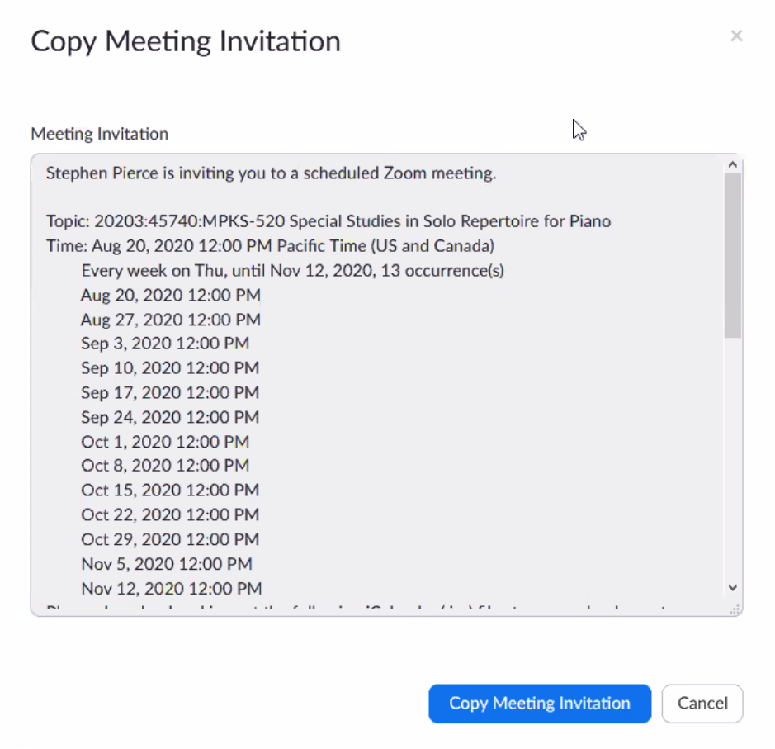
- Logon to Blackboard.
- Create an Announcement as shown in this video for the second of the two class instances that are double-booked.
  - Paste the meeting invitation in the Announcement along with a note to your students to use that link for first week of class.

