Delete a Zoom Instance

- Log onto usc.zoom.us.

- Click Meetings in the left panel.

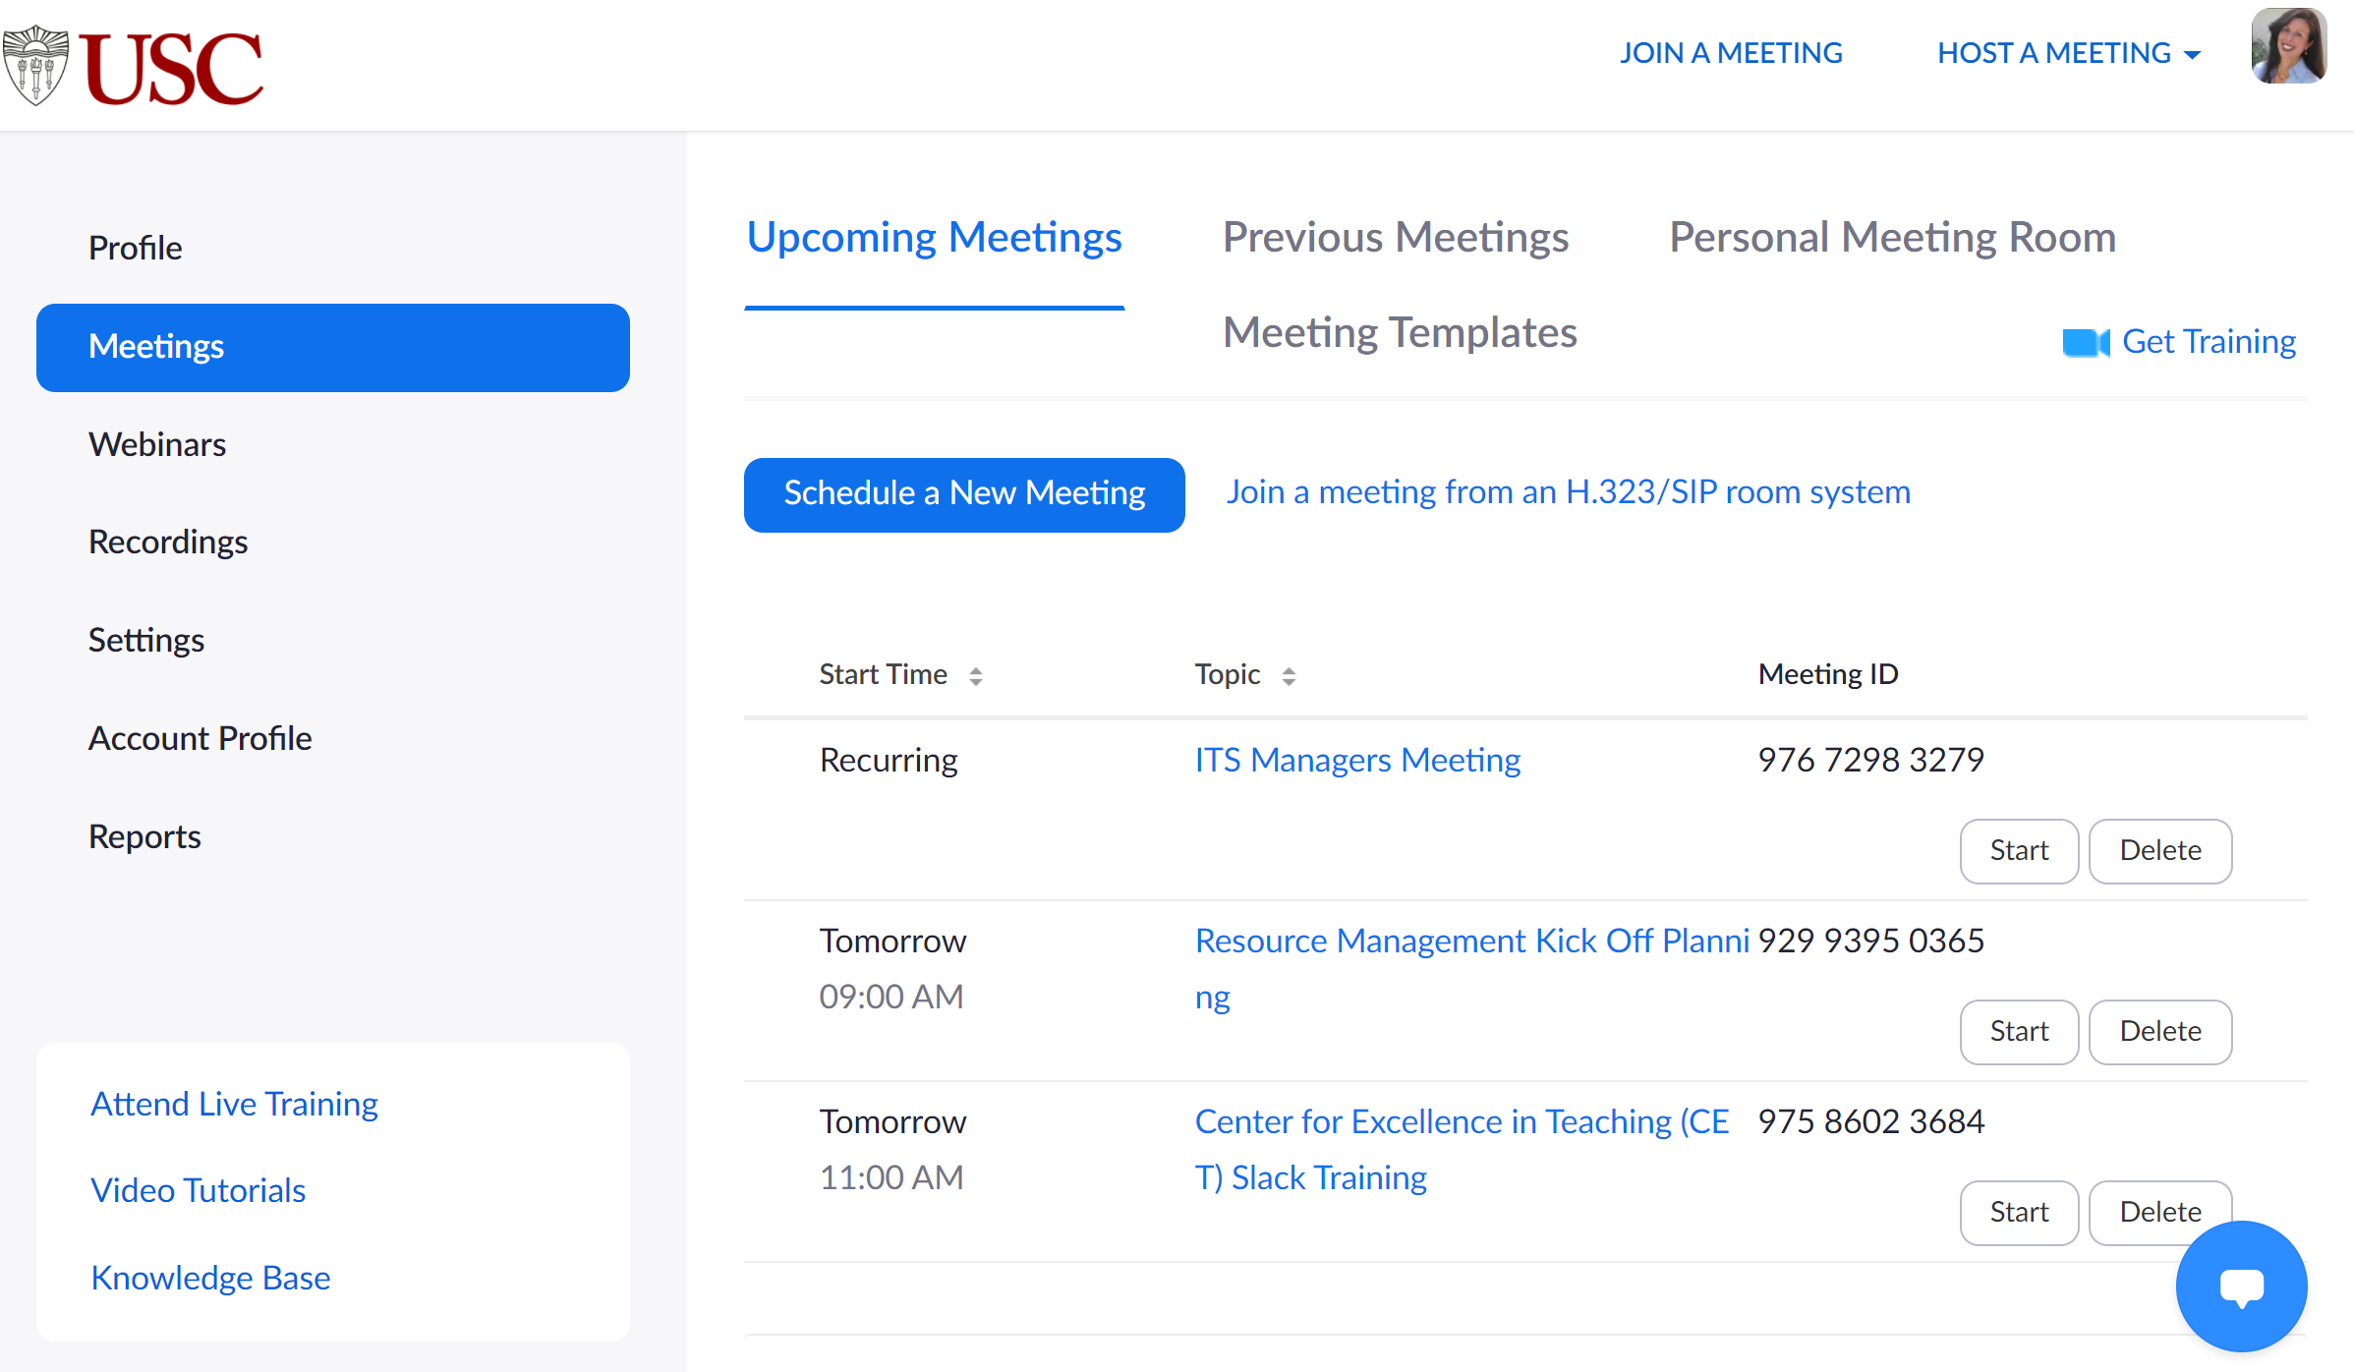
- Click the Delete button next to the meeting instance for the lab.

